Instructions – For Android or PC

Go to <https://www.jonesneil.com>

The demo works only when the website is accessed on https

You will be faced with an error because I haven’t added any certificate to the website.

Click on Advanced

In the next page. Click on this.

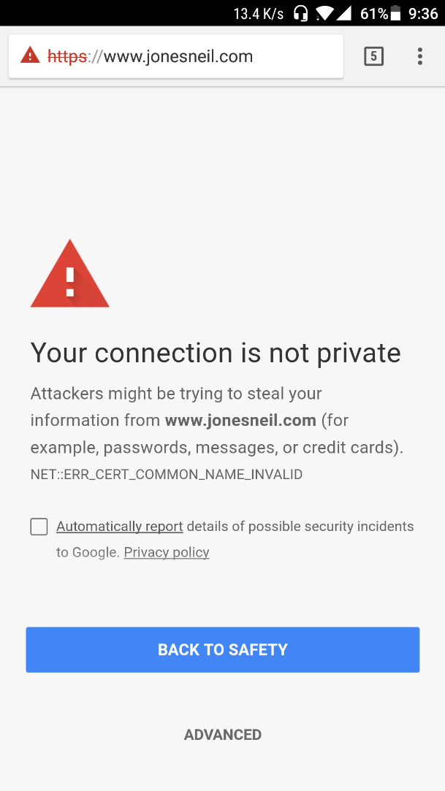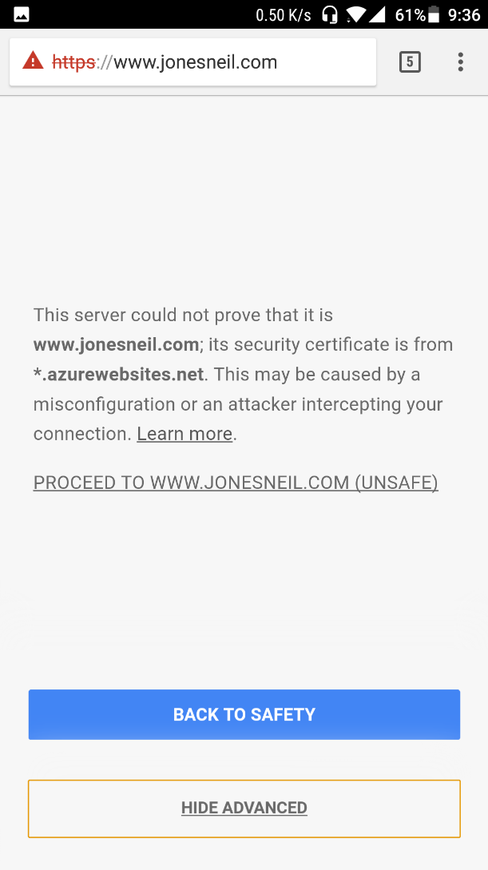



The initial rendering will take a few seconds. So after loading the AR Demp, keep the phone pointed to this pattern for around 5 seconds.

Nathan Doe

123.456.7890

[nathan.doe@gmail.com](mailto:nathan.doe@gmail.com)

**H**eight: 6’2” **W**eight: 185 **H**air: Brown **E**yes: Green

|  |  |  |
| --- | --- | --- |
| **Theatre:** |  | |
| The Nativity | Joseph | United Methodist Church |
| Hamlet | Spear Holder | Springfield High School |
| Little Johnny’s First Tooth | Little Johnny | Springfield Children’s Theatre |

# Training:

## Artist Theatre Association’s Summer Intensive ’09

Springfield, NY

## Intro to Acting, Springfield High School

Springfield, NY

# Special Skills:

Beginner Guitar, Intermediate Spanish, Driver’s License, Passport

Scenario

Looking for Office space

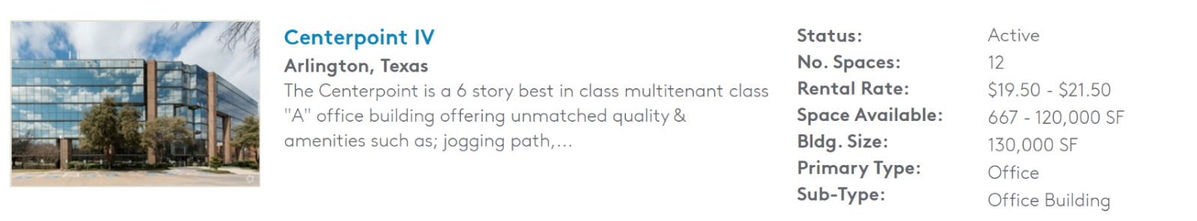

------------------------------------------------------------------- FOLD HERE -----------------------------------------------------------------------

Scenario

ADVERTISEMENT

